SIMATS ENGINEERING
ASSESSMENT TOOL 2: Error Analysis Task

COURSE NAME: Cloud Computing and
Big Data Analytics

COURSE CODE: CSA1515

COURSE OUTCOME COVERED
CO5: Design big data processing systems using the Hadoop ecosystem including HDFS, MapReduce, and YARN.
(BL5)
Assessment Tool Weightage: 20%
Dave&#39;s Taxonomy: Articulation (Level 4)
Question Count: 5

Total Marks: 25

Code of Conduct
I __ARTHI REDDY(192565054)_(Name / Reg No) certify that this submission is my original work and that I have adhered
to the guidelines specified for this assessment.
I understand that any violation of academic integrity rules will result in disciplinary action.
Signature of the student: ____________________

Assessment Tasks
Error Analysis Task
1. A Hadoop job repeatedly fails because input splits are uneven and reducers remain idle. Identify the likely
design error and propose corrective actions.
2. An HDFS deployment shows frequent data unavailability after a single node failure. Analyze the probable
replication or NameNode design error.
3. A data ingestion workflow using ETL and Apache NiFi creates duplicate records in the analytics store. Identify
the likely causes and recommend fixes.
4. A YARN cluster suffers from resource starvation when multiple users submit jobs together. Analyze the
scheduling error and suggest a better resource management approach.
5. A backup strategy for distributed storage restores outdated data after recovery. Identify the probable design
flaw in the replication or backup approach.
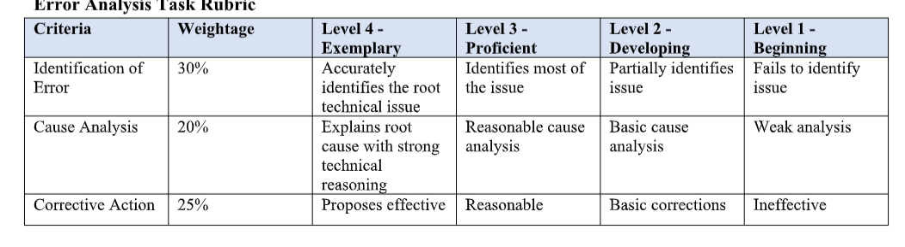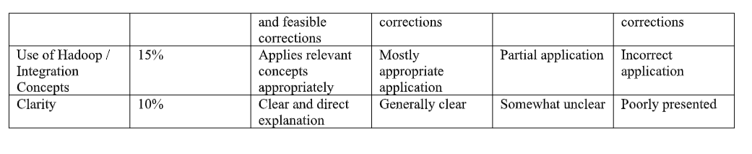

1. Hadoop Job Fails Due to Uneven Input Splits
Problem Analysis
The likely design error is data skew or improper input-split configuration. Some Mapper tasks receive much more data than others, causing a few tasks to run longer while reducers remain idle.
Corrective Actions
- Use appropriate HDFS block size and input split size.
- Enable CombineFileInputFormat for many small files.
- Partition data more evenly.
- Use a Combiner to reduce intermediate data.
- Check for skewed keys and use better partitioning.
- Balance the number of Mapper and Reducer tasks.
Conclusion
Proper data partitioning, balanced input splits, and key distribution prevent mapper imbalance and reducer idling.

2. HDFS Data Unavailability After Single Node Failure
Problem Analysis
The probable error is insufficient replication or poor NameNode configuration.
Possible causes:
- Replication factor is set to 1 or too low.
- Replicas are stored on the same rack/node.
- NameNode is a single point of failure.
- HDFS block replication is incomplete.
Corrective Actions
- Set replication factor to 3 for important data.
- Enable rack-aware replica placement.
- Configure NameNode High Availability (HA) with Active and Standby NameNodes.
- Monitor under-replicated blocks.
- Use automatic block re-replication after node failure.
Conclusion
3-way replication + rack awareness + NameNode HA ensures data remains available even after a node failure.

3. Duplicate Records in ETL and Apache NiFi
Problem Analysis
Duplicates can occur because the ingestion pipeline processes the same data more than once.
Likely Causes
- NiFi flow is triggered repeatedly for the same input.
- No unique record ID is maintained.
- ETL job retries without checking whether data was already inserted.
- Lack of idempotent processing.
- Failure during acknowledgement causes the same file/record to be reprocessed.
Corrective Actions
- Assign a unique ID to every record.
- Use NiFi processors such as DetectDuplicate.
- Maintain transaction/checkpoint information.
- Use database UPSERT/MERGE instead of blind INSERT.
- Design the pipeline to be idempotent.
- Maintain audit logs for processed files and records.
Conclusion
Using unique IDs, duplicate detection, checkpoints, and idempotent processing prevents duplicate records.

4. YARN Resource Starvation
Problem Analysis
The likely scheduling error is that resources are being allocated without proper queue management, capacity limits, or fairness controls. One or a few users/jobs may consume most of the cluster resources.
Corrective Actions
- Use Capacity Scheduler or Fair Scheduler.
- Create separate queues for different teams/users.
- Set minimum and maximum resource capacity for each queue.
- Apply resource quotas for users and applications.
- Use job priorities carefully.
- Enable preemption when necessary.
- Monitor CPU and memory utilization.
Example Queue Design
Queue | Resource Allocation | Priority
ETL | 40% | High
Reporting | 30% | Medium
ML | 30% | Medium
Conclusion
Using queues, quotas, priorities, and fair resource allocation prevents resource starvation and allows multiple users to run jobs together.

5. Backup Restores Outdated Data
Problem Analysis
The probable design flaw is that the backup system is restoring an old snapshot or stale replica instead of the latest valid data.
Likely Causes
- Backup schedule is too infrequent.
- Replicas are not synchronized.
- No backup version tracking.
- Recovery process selects the wrong snapshot.
- Replication is being treated as a replacement for backup.
- Failed/incomplete backups are not detected.
Corrective Actions
- Schedule regular incremental and full backups.
- Maintain multiple backup versions.
- Add timestamps and version numbers to backups.
- Verify backup integrity after creation.
- Monitor replication lag.
- Use the latest verified backup during recovery.
- Test restoration periodically.
Conclusion
A reliable strategy should combine synchronized replication, versioned backups, integrity checks, and regular recovery testing to ensure the latest correct data is restored.

